Literature 165: Nietzsche, Marx, and Freud

## Spring 2012, RS 103

John Farrell **Office Hours:**

x72656 RS 217

jfarrell@cmc.edu T-Th 2:45-4

**Texts:**

Balzac, Père Goriot (Norton) 978039397166

Edward Bellamy, Looking Backward (Signet) 0451527631

Bacchae of Euripides, trans C. K. Williams (FSG ) 9780374522063

Freud, “Forgetting of Foreign Words,” from The Psychopathology of Everyday Life (Sakai)

Peter Gay, The Freud Reader (Norton) 0393314030

R. J. Hollingdale, A Nietzsche Reader (Penguin) 0140443290

Nietzsche, Prologue and from Book One of Thus Spoke Zarathustra (Sakai)

Plato, Apology (Sakai)

Alexander Pope, An Essay on Man and Other Poems (Dover Thrift) 0486280535

J.-J. Rousseau, Discourse on the Origins of Inequality (Hackett) 0872201503

Robert Tucker, 2nd ed. The Marx-Engels Reader (Norton) 0393056848

Voltaire, Candide (Dover Thrift) 0486266893

***Preparatory Developments***

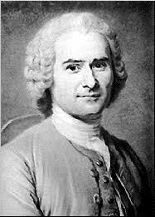

***Jean-Jacques Rousseau***

Jan 17: Introduction

Jan 19: Pope, Essay on Man

Adam Smith, The Wealth of Nations, chs. 1-2

Theory of the Moral Sentiments, from ch. 1 of Part 4

Jan 24: Voltaire, Candide; Rousseau, Discourse

Jan 26: Balzac, Père Goriot

Jan 31: Balzac, Père Goriot

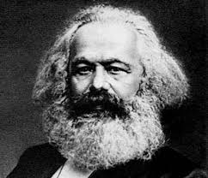

***Karl Marx***

(pages from The Marx-Engels Reader)

Feb 2: [with Engels], The Communist Manifesto, 469-500

Friedrich Engels, from The Condition of the English Working Classes, 579-86

Feb 7: From Manuscripts of 1844, 66-105

Feb 9: On the Jewish Question, 26-52

Feb 14: “Theses on Feuerbach,” 143-46

[with Engels] From The German Ideology, 147-200

Feb 16: From Adam Smith, The Wealth of Nations, ch 5

Wage Labour and Capital, 203-17

From Capital, vol. 1, 302-76

From the Grundrisse (on automation), 278-84

Feb 21: The Civil War in France, 616-52

Replies to Bakunin, 542-48

Feb 23: From the Grundrisse (on art), 245-46;

Looking Backward

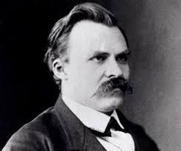

***Friedrich Nietzsche***

(pages from The Nietzsche Reader)

Feb 28: Socrates vs. Euripides: The Apology and The Bacchae

Mar 1: “On Truth and Lie in an Extra-Moral Sense” (Sakai)

Mar 6: Preface; Philosophy and Philosophers, 15-53

Mar 8: Logic, Epistemology, and Metaphysics, 53-71

Mar 13 & 15: SPRING BREAK

Mar 20: Morality, 71-125

Mar 22: Genealogy of Morals, parts 1 & 2

Mar 27: Genealogy of Morals, part 3;

Art and Aesthetics, Psychological Observations, Religion, 125-196

Mar 29: Nihilism & Anti-Nihilism, 197-214

Apr 3: Will to Power, Superman, Eternal Recurrence, 215-64;

Prologue and from Book One of Thus Spoke Zarathustra (Sakai)

Apr 5: Ecce Homo, parts 1-3

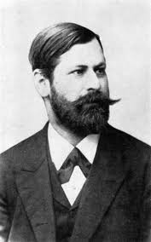

***Sigmund Freud***

(pages from The Freud Reader)

Apr 10: An Autobiographical Study, 3-44

Joseph Breuer, “Anna O.,” 60-77

Freud, The Aetiology of Hysteria, 96-110

Letters to Fliess, 111-16

Apr 12: The Interpretation of Dreams, 129-41

“On Dreams,” 142-171

“Fragment of an Analysis of a Case of Hysteria,” 172-238

“Observations on Transference-Love,” 378-86

“Forgetting of Foreign Words” (Sakai)

Apr 17: “Character and Anal Erotism,” 293-96

“Family Romances,” 297-300

“Formulations on the Two Principles of Mental Functioning,” 301-306

“Obsessive Actions and Religious Practices,” 429-35

“Creative Writers and Day-Dreaming,” 436-42

Apr 19: Leonardo da Vinci and a Memory of His Childhood, 443-80

Apr 24: “From the History of an Infantile Neurosis” (“Wolf Man”), 400-26

Apr 26: “On Narcissism: An Introduction,” 545-61

“Instincts and Their Vicissitudes,” 562-67

“Repression,” 568-71

“The Unconscious,” 572-83

“Mourning and Melancholia,” 584-88

“The Dissolution of the Oedipus Complex,” 661-65

May 1: Civilization and Its Discontents, 722-71

**Essays** (2000 words):Friday, **Feb 24** (15%); Friday, **April 6** (20%); Thursday, **May 3** (20%). Topics must be approved one week before the deadline for each essay. Before writing, all students are advised to review items 3, 7, 14, and 30 in the Sakai doc “Technical Aspects of Writing.” There will also be a 750-word preliminary essay due on **Jan 27**.

**Final Exam:** Tuesday, May 8, 9:00 AM (40%)

**Senior final:** Thursday, May 3 at noon in RS 105

**Supplementary documents (Sakai):**

Technical Aspects of Writing

Twelve Steps toward a Successful Literary Analysis

Chronology